Supplementary materials
Impact of Textile Dyes on Health and Ecosystem: A Review of Structure, Causes and Potential Solutions

Tarekul Islam^{1,2}, Md. Reazuddin Repon^{2, 3,4, *}, Tarikul Islam^{2,5}, Zahid Sarwar⁶ and Mohammed M. Rahman⁷

¹Department of Textile Engineering, Mawlana Bhashani Science and Technology University, Tangail-1902, Bangladesh
²ZR Research Institute for Advanced Materials, Sherpur-2100, Bangladesh
³Department of Textile Engineering, Khwaja Yunus Ali University, Sirajgang-6751, Bangladesh
⁴Department of Production Engineering, Faculty of Mechanical Engineering and Design, Kaunas University of Technology, Studentų 56, LT-51424, Kaunas, Lithuania
⁵Department of Textile Engineering, Jashore University of Science and Technology, Jashore-7408, Bangladesh
⁶School of Engineering and Technology, National Textile University, Faisalabad, Pakistan
⁷Center of Excellence for Advanced Materials Research (CEAMR) & Department of Chemistry, Faculty of Science, King Abdulaziz University, Jeddah 21589, Saudi Arabia

*Corresponding address:
Md. Reazuddin Repon
Researcher, Department of Production Engineering
Faculty of Mechanical Engineering and Design
Kaunas University of Technology, Studentų 56, LT-51424, Kaunas, Lithuania
Email: reazmbstu.te@gmail.com ; md.repon@ktu.edu
Cell: +37066227098
Supplementary tables:
Table S1. Classification of dyes based on textile usage, chemical constitution and solubility (Broadbent 2001; Samsami et al. 2020)
Classification |  |  | Types | Refs.
Based textile usage |  |  | - Azoic dyes  - Acid dyes  - Basic dyes  - Direct dyes  - Disperse dyes  - Mordant dyes  - Pigments  - Reactive dyes  - Sulfur dyes  - Vat dyes | (Broadbent 2001)
Based on chemical constitution |  |  | - Azo dyes  - Anthraquinone dyes  - Heterocyclic dyes  - Indigoid dyes  - Nitro dyes  - Phthalocyanine dyes  - Polymethine dyes  - Stilbene dyes  - Sulfur dyes  - Triphenylmethane dyes
Based on solubility | Soluble | Anionic | - Acid dyes  - Direct dyes  - Mordant dyes  - Reactive dyes | (Samsami et al. 2020)
 |  | Cationic | - Basic dyes
 | Insoluble |  | - Azo dyes  - Disperse dyes  - Mordant dyes  - Sulfur dyes  - Vat dyes

Table S2. The industrial dyes according to their application class, characteristics and application with structure.
Class of dye | Structure | Characteristics and application
Acid | 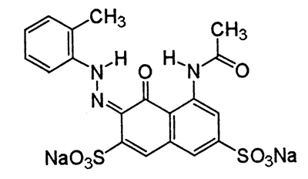Acid Red 35 | Characteristic: The size of the dye molecule has a direct relationship with color fastness (Walters, A., Santillo, D., & Johnston 2005)
 |  | Applications: Acid dyes are used on a variety of textile substrates: wool, silk, paper, inks, leader, polyamide, cosmetics, ink-jet printing etc.
Reactive | 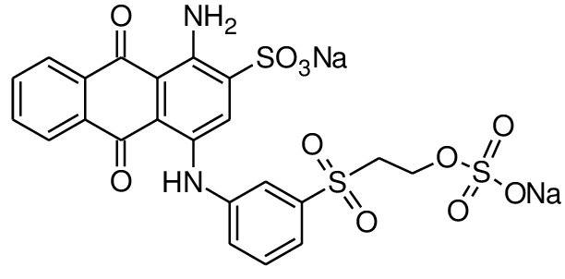Reactive Blue 19 | Characteristics: Dyeing with reactive dye takes less time and is done at a lower temperature (above 60°) (Chiou and Li 2002; Pei et al. 2017). This dyes are now in powder, liquid, and print paste forms and are water soluble.
 |  | Applications: For dyeing cellulose, protein, and polyamide fibers, reactive dyes are utilized (Mathur et al. 2012).
Disperse | 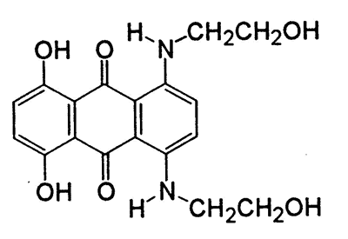Disperse Blue 7 | Characteristics: Disperse dyes are comparatively low molecular weight (range; 400-600), slightly water soluble and substantive to hydrophobic fibers (Nylon & Polyester) (Ding et al. 2020).
 |  | Applications: The only dyes that may be used to dye poly (ethylene terephthalate) are disperse dyes. Furthermore, cellulose acetate, nylon, and polyester fibers are dyed with disperse dyes.
Direct | 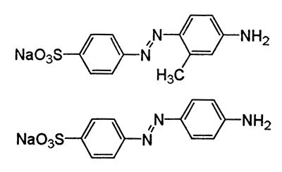Direct Orange 36 | Characteristic: Direct dyes are less expensive than indirect dyes (Zinatloo-Ajabshir et al. 2017).
 |  | Applications: Cotton, viscose, paper, leather, and cellulose fibers are dyed with direct dyes.
Basic | 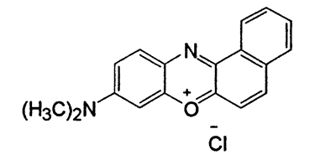CI Basic Blue 6 | Characteristics: The basic dyes are less expensive, not easily soluble in water but soluble in alcohol and methyted spirit (2015).
 |  | Applications: Basic dyes are used in paper, inks and synthetic fibers.
Vat | 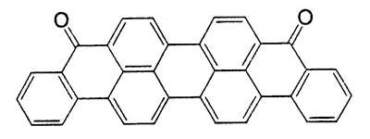Vat Blue 20 | Characteristics: Vat dyes are water soluble, the reduced dyes has substantivity to cellulose, exhibit excellent wet and light fastness and after dyeing soluble dyes are oxidized with in the fabric to form insoluble again(Khatri et al. 2015).
 |  | Applications: Vat dyes are used in viscose, wool, cotton and cellulose. Besides, this dyes are used in superior quality shirting material, military uniforms, furnishing, toweling and denim.
Sulfur | 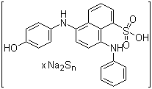Sulfur brilliant green, CI 53570 | Characteristics: Sulfur dyes are water insoluble, it needs solubilization for application, and this dyes are used in alkaline condition. Additionally, electrolyte can be injected to the dye to enable faster the dye exhaustion process, which is optimal for generating black and brown on textile materials at a temperature of 90° (Chakraborty and Jaruhar 2014).
 |  | Applications: Sulfur dyes are mainly applied on cotton, viscose and staple fibers (Nguyen and Juang 2013).
Azoic | 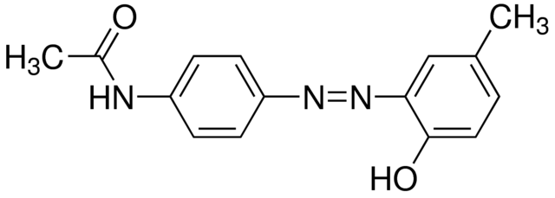Disperse Yellow 3 | Characteristics: Azoic dyes are water insoluble, They aren't dyes that have been pre-mixed. The color is generated in the fiber by two main components typically known as "Napthols" and "Bases". The dyed goods exhibit good to excellent light fastness and good washing fastness (Walters, A., Santillo, D., & Johnston 2005; Hassan and Carr 2018)
 |  | Applications: Azoic dyes are used in textile fibers such as cellulose acetate, polyester, rayon and cotton.
Mordant | 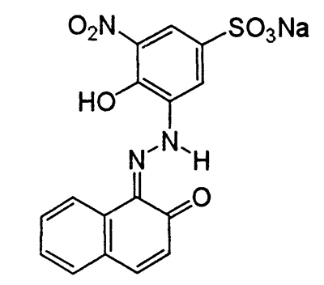Mordant Blue 17 | Characteristics: Many standard mordant dyes form stable complex on the Nano crystalline surface TiO₂ (Millington et al. 2007), some types of textile substrates have a poor affinity for them. These dyes are also anticipating a reaction from their industrial applications (2009).
 |  | Applications: Textile fibers such as silk, leather, and wool are dyed with mordant dyes.
 | 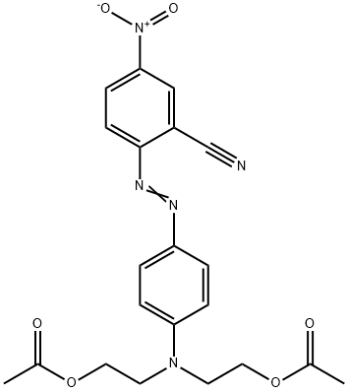Disperse Red 82 | Characteristic: Disperse azo dyes have a lower water solubility (Vacchi et al. 2016).
 |  | Applications: This dyes are used in polyester, polyamide and plastic.

Table S3. Chemical class distribution across major application ranges (%) (Suteu, Zaharia and Malutan, 2012; R Ananthashankar, 2013).
Chemical class | Distribution between application ranges, (%)
 | Acid | Basic | Direct | Disperse | Mordant | Pigment | Reactive | Solvent | Vat
Unmetallised azo | 21 | 4 | 30 | 12 | 11 | 7 | 9 | 6 | -
Metal complex | 64 | - | 11 | - | - | - | 13 | 12 | -
Thiazole | - | 6 | 94 | - | - | - | - | - | -
Stilbene | - | 3 | 97 | - | - | - | - | - | -
Anthraquinone | 14 | 3 | - | 26 | 2 | 4 | 5 | 10 | 36
Indigoid | 2 | - | - | - | - | 18 | - | - | 80
Quinophthalene | 30 | 20 | - | 40 | - | - | 10 | - | -
Aminoketone | 10 | - | - | 40 | 8 | - | 3 | 8 | 21
Phtalocyanine | 15 | 3 | 8 | - | 4 | 10 | 42 | 16 | 2
Formazan | 69 | - | - | - | - | - | 31 | - | -
Methine | - | 70 | - | 24 | - | 2 | - | 4 | -
Nitro, nitroso | 30 | 3 | - | 48 | 3 | 4 | - | 12 | -
Triarylmethane | 36 | 21 | 1 | 1 | 24 | 4 | - | 13 | -
Xanthene | 32 | 16 | - | - | 10 | 2 | 2 | 38 | -
Acridine | - | 92 | - | 4 | - | - | - | 4 | -
Azine | 40 | 40 | - | - | - | 2 | - | 18 | -
Oxazine | - | 23 | 16 | 2 | 39 | 10 | 10 | - | -
Thiazine | - | 56 | - | - | 10 | - | - | 10 | 24

Table S4. Different dye classes have varying rates of fixation on different textile substrates (Dos Santos, Cervantes and Van Lier, 2003; Scalbi, Tarantini and Mattioli, 2005; Avvannavar, Mani and Kumar, 2008; Mani, Chowdhary and Bharagava, 2019).
Dye class | Fiber type | Fixation rate (%) | Effluent rate (%)
Acid | Polyamide | 90-95 | 5-10
Azo | Cellulose | 90-95 | 5-10
Basic | Acrylic | 90-100 | 0-10
Direct | Cellulose | 75-95 | 5-25
Disperse | Polyester | 95-100 | 0-5
Metal complex | Wool | 95-98 | 2-5
Reactive | Cellulose | 50-90 | 10-50
Sulfur | Cellulose | 65-90 | 10-35
Dye-stuff | Cellulose | 85-95 | 5-15
Vat | Cellulose | 80-95 | 5-20

Table S5. A typical textile industry effluent in terms of physio-chemical characteristics
Factor/ Parameter | Reported value* | References
BOD | 237.2±32.1 | (Kaur et al. 2018; Tara et al. 2019; Hussain et al. 2019; Chandanshive et al. 2020)
TDS | 8850±756 | (Khan and Malik 2014; Chandanshive et al. 2017; Kaur et al. 2018; Kadam et al. 2018)
COD | 1268±121 | (Chandanshive et al. 2017; Kaur et al. 2018; Kadam et al. 2018; EL-Mekkawi et al. 2020)
P^{H} | 8.75±1.29 | (Hussain et al. 2019; Oktem et al. 2019)
TSS | 253.2±43.5 | (Guadie et al. 2017; Tara et al. 2019; Hussain et al. 2019; EL-Mekkawi et al. 2020)
TS | 5076±344 | (Tara et al. 2019; Hussain et al. 2019)
EC | 7.1±1.72 | (Tara et al. 2019; Hussain et al. 2019)
TOC | 222.2±53.3 | (Tara et al. 2019; Hussain et al. 2019; Ağtaş et al. 2021)
Cl⁻ | 51.6±16 | (Tomei et al. 2016; Guadie et al. 2017)
Cr | 2.74±0.4 | (Chandanshive et al. 2017, 2020; Watharkar et al. 2018; Hubadillah et al. 2020)
Pb | 0.35±0.3 | (Amare et al. 2017; Chandanshive et al. 2017, 2020; Hubadillah et al. 2020)
AIk | 396±132 | (Guadie et al. 2017; Arcanjo et al. 2018)
SO₄²⁻ | 240.6±75.4 | (Arcanjo et al. 2018; Hussain et al. 2019)
TN | 24.4±11.7 | (Guadie et al. 2017; Tara et al. 2019; Hussain et al. 2019; EL-Mekkawi et al. 2020)
Phenol | 0.52±0.22 | (Tara et al. 2019; Hussain et al. 2019)
As | 2.21±0.4 | (Chandanshive et al. 2017, 2020; Watharkar et al. 2018; Kadam et al. 2018)
Zn | 0.37±0.37 | (Amare et al. 2017; Hubadillah et al. 2020)
NO₃⁻ | 116.1±109 | (Arcanjo et al. 2018)
Cu | 0.54±0.5 | (Amare et al. 2017; Hubadillah et al. 2020)
PO₄³⁻ | 12.4±3.2 | (Guadie et al. 2017; Tara et al. 2019; Hussain et al. 2019; EL-Mekkawi et al. 2020)
Cd | 0.62±0.3 | (Tara et al. 2019; Hussain et al. 2019; Hubadillah et al. 2020; Chandanshive et al. 2020)
Note: All the values are means of triplicates (n = 3) ± SD.
*Except pH, all the parameters are expressed in “mgL⁻¹”, but the conductivity is expressed in “μmho/cm”.

Supplementary figures:

Figure S1. Major sectors that discharge dyes into the environment. Reproduced with permission (Samsami et al. 2020). Copyright 2020, Elsevier.

Figure S2. International textile dyes market over the forecasted period of 2016–2023. Reproduced with permission (Samsami et al. 2020). Copyright 2020, Elsevier.
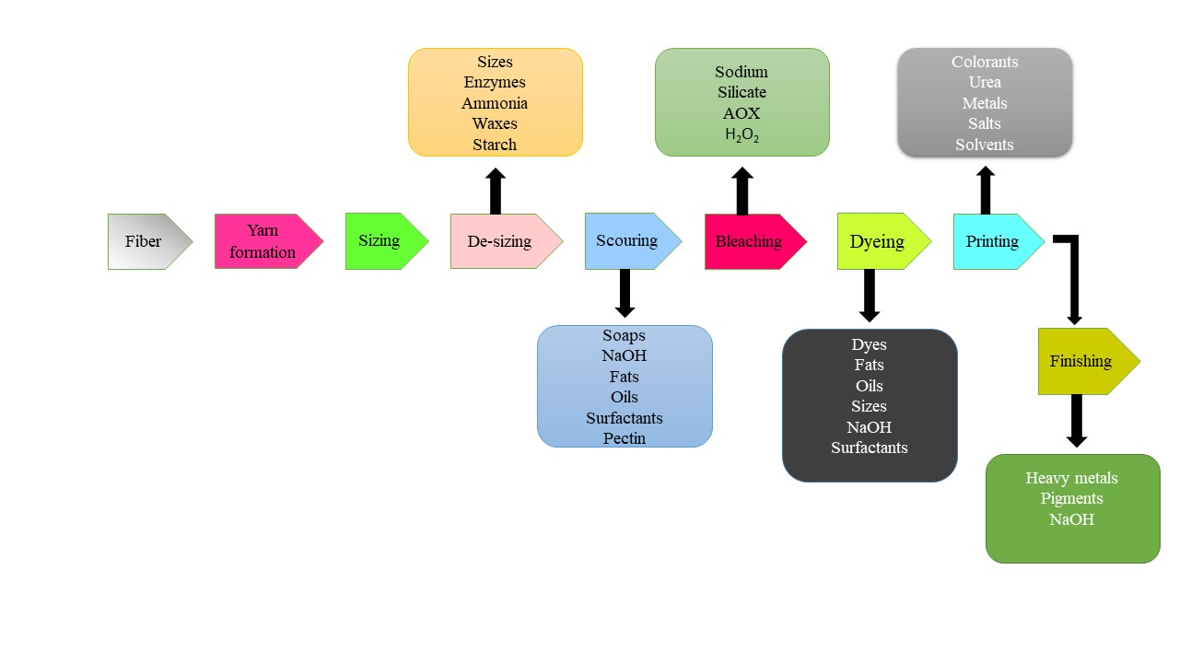
Figure S3. Different wet processing steps in the textile industry and some pollutants propagated from these steps.

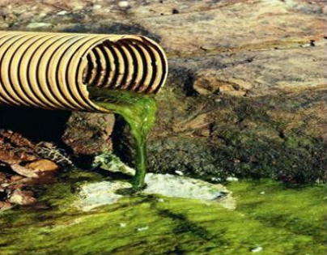 | 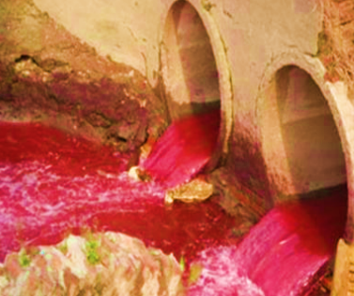 | 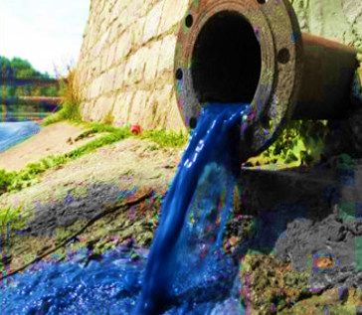
Figure S4. Discharge colored dyes from textile industries.

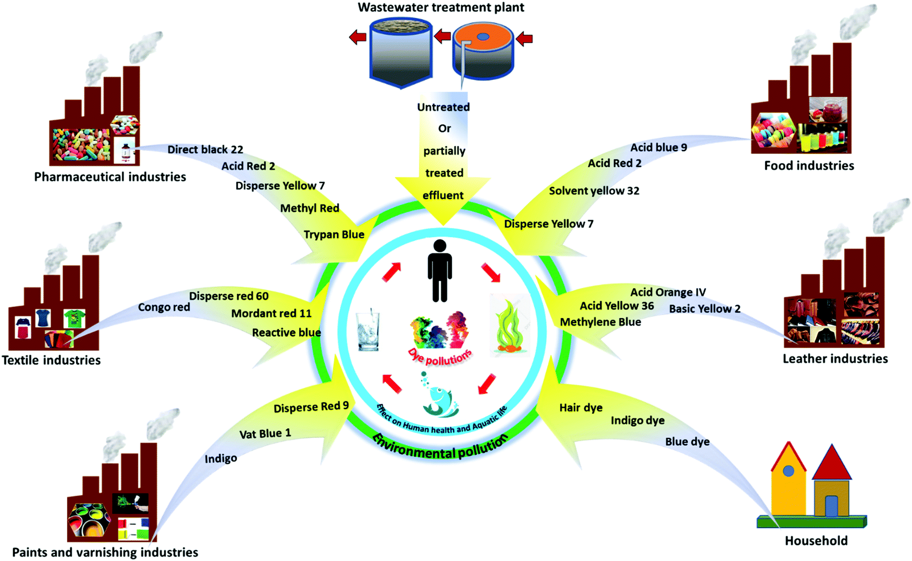
Figure S5. Sources and pathways of dyes in the eco-system (Dutta et al. 2021).
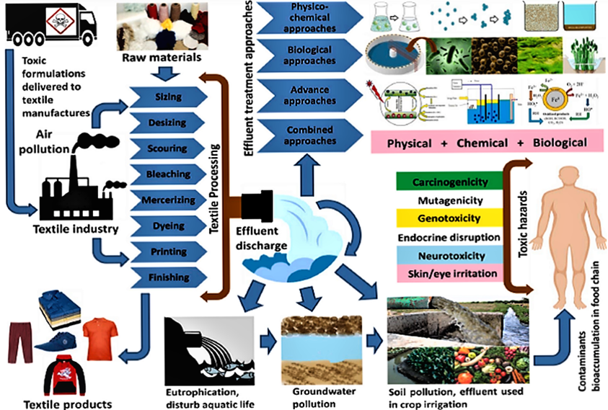
Figure S6. Manufacturing processes in textile industry, wastewater discharge, negative impacts and several remedial techniques. Reproduced with permission (Kishor et al. 2021). Copyright 2021, Elsevier.
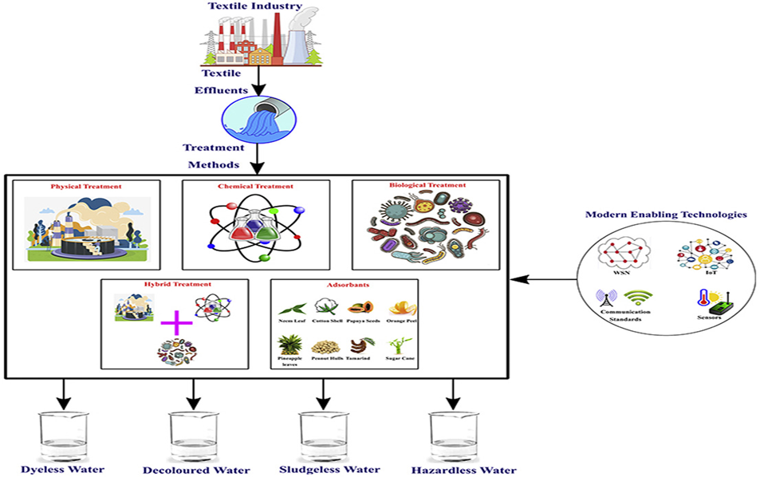
Figure S7. Industrial dye effluent techniques (Hynes et al. 2020).
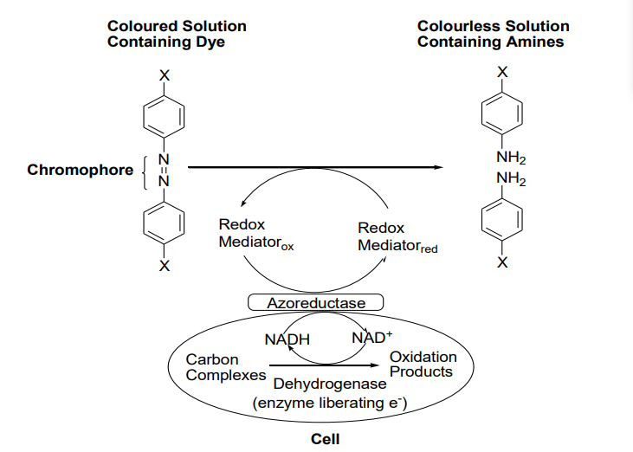Figure S8. Suggested mechanism for reduction of azo dyes by azo reductase. Reproduced with permission (Pearce et al. 2003). Copyright 2003, Elsevier.
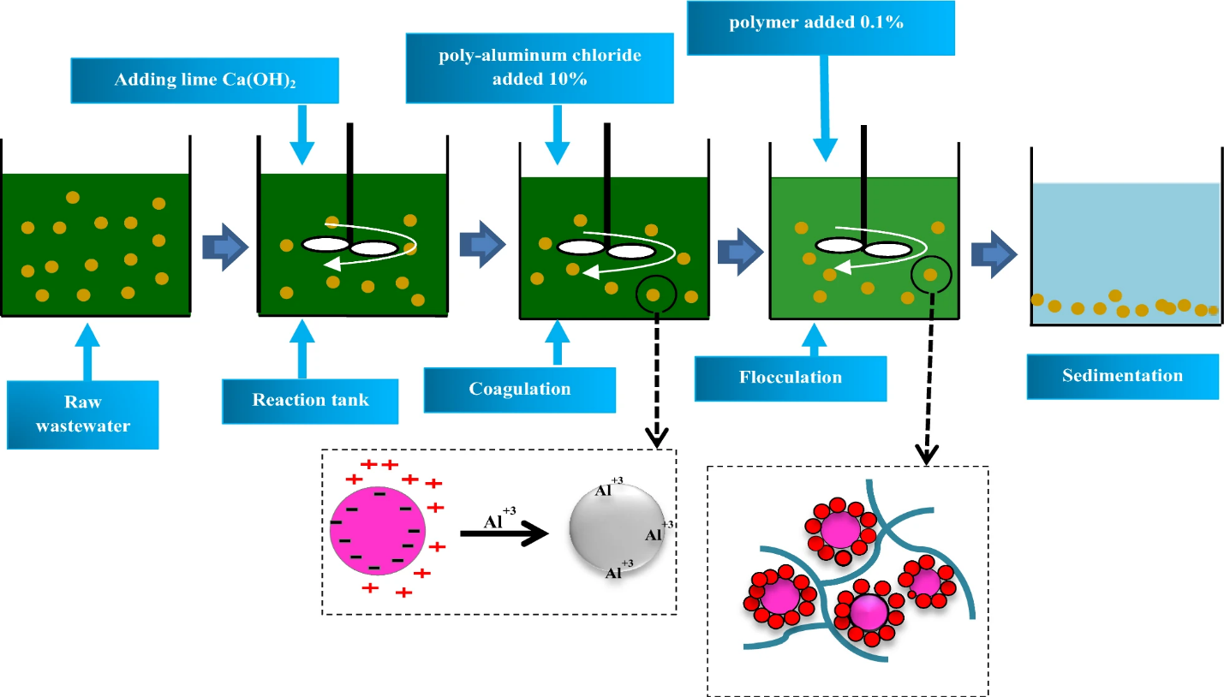
Figure S9. schematic illustration of coagulation-flocculation for wastewater treatment (B) (Choumane et al. 2017).

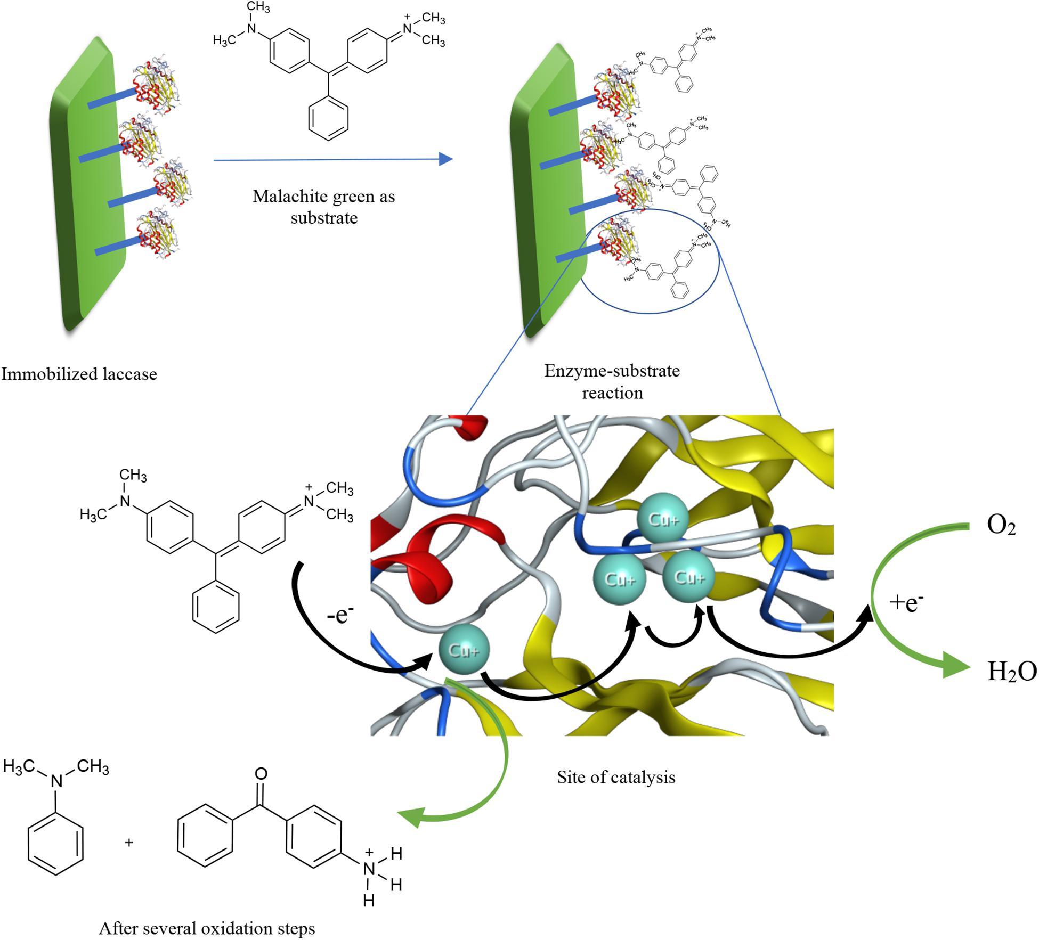
Figure S10. A proposed mechanism of dye de-colorization by immobilized laccase with the aid of the crystal structure of laccase from Thermus thermophilus HB27 (Morsy et al. 2020).

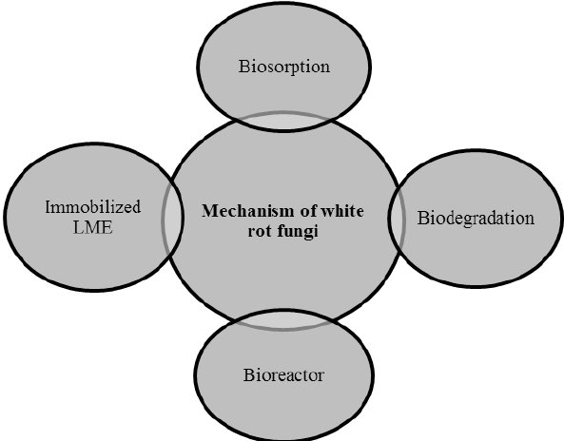
Figure S11. Process in the removal of dyes using white rot fungi (Jebapriya and Gnanadoss 2013).
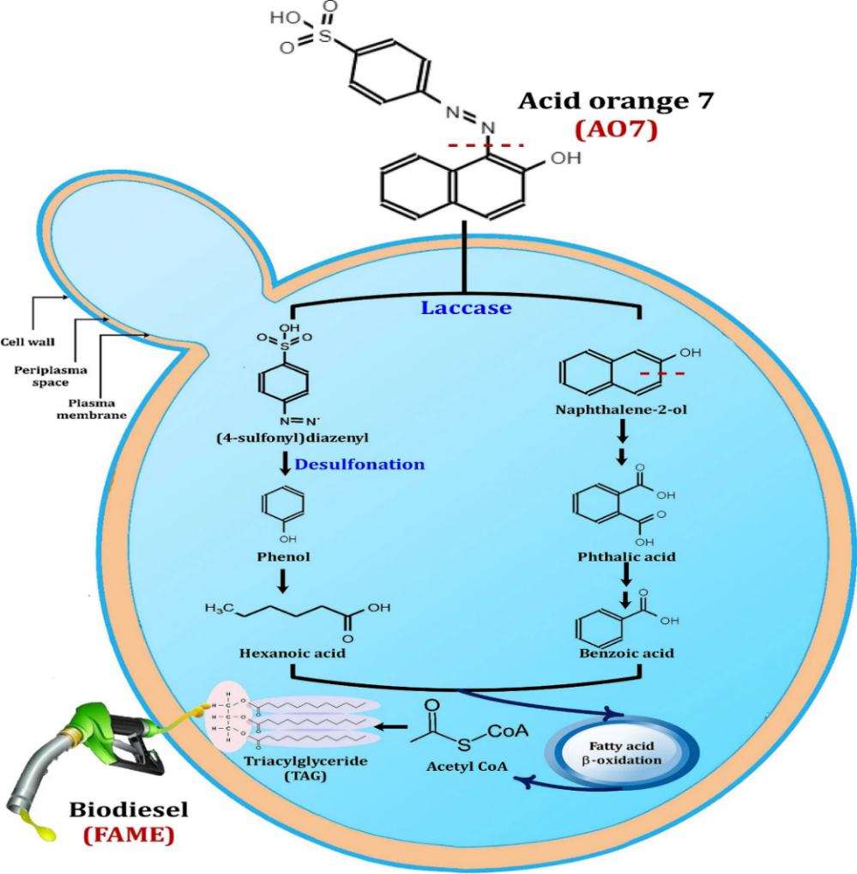
Figure S12. The azo dye (AO7) degradation pathway by the oleaginous yeast consortium NYC-1 linked to biodiesel synthesis. (Ali et al. 2021).
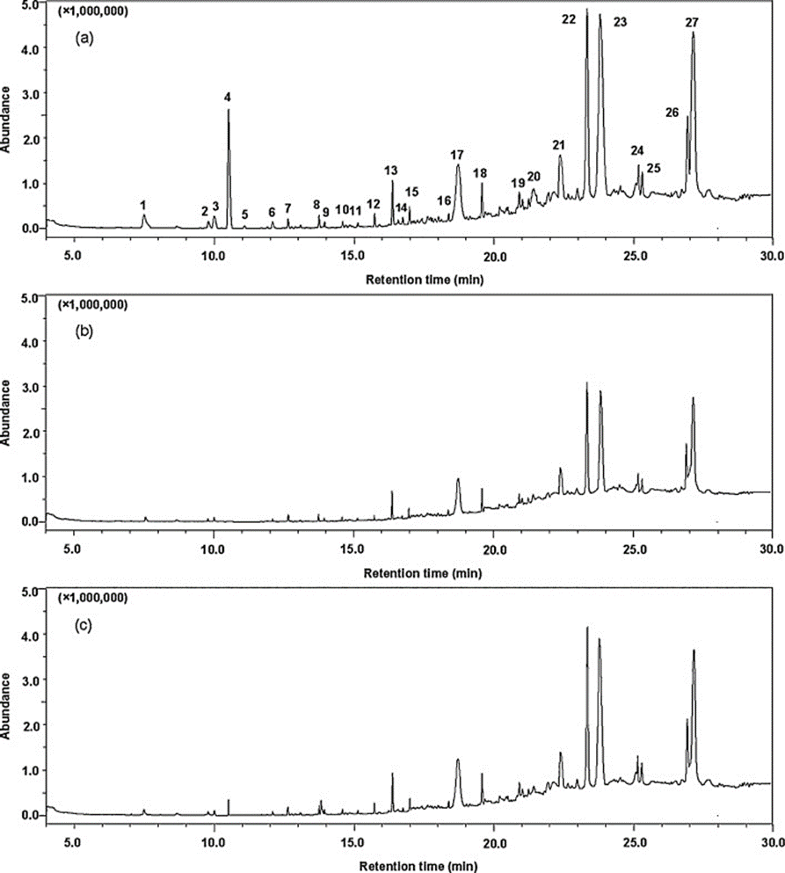
Figure S13. GC–MS chromatograms of: (a) raw wastewater, (b) treated by microbubble-ozonation, and (c) treated by macrobubble-ozonation. Reproduced with permission (Zheng et al. 2015). Copyright 2015, Elsevier.

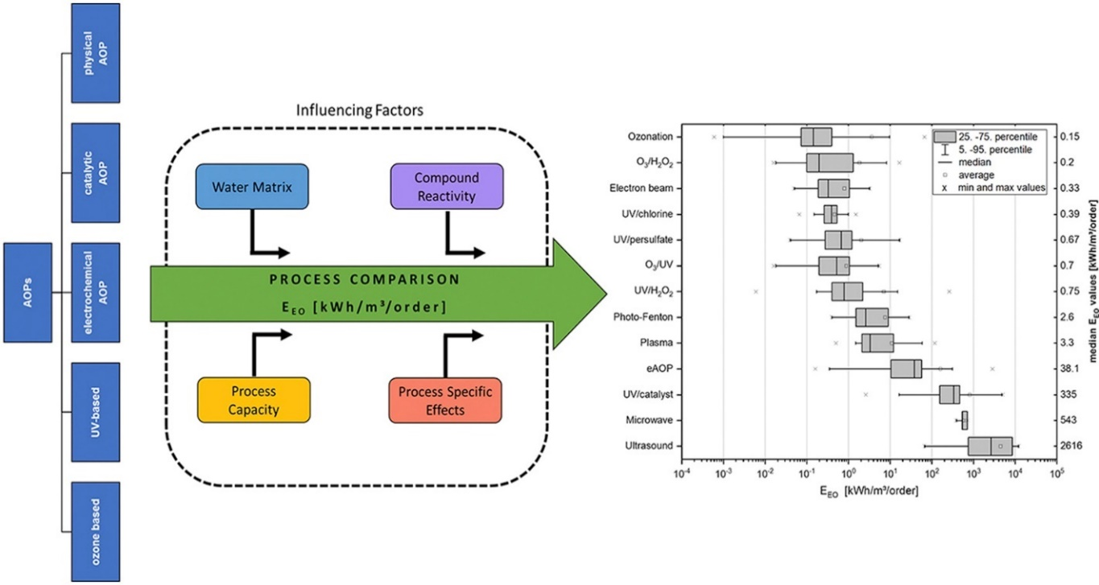
Figure S14. Broad overview and classification of different AOPs, influencing factors and published E_{EO}-values of different AOPs sorted according to median values. Reproduced with permission (Miklos et al. 2018). Copyright 2018, Elsevier.
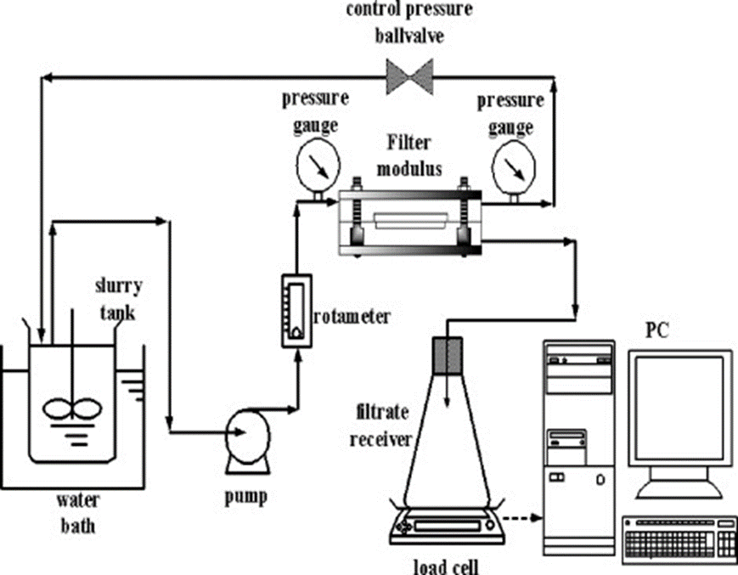
Figure S15. Schematic diagram of the MF experimental apparatus. Reproduced with permission (Lu and Liu 2010). Copyright 2010, Elsevier.
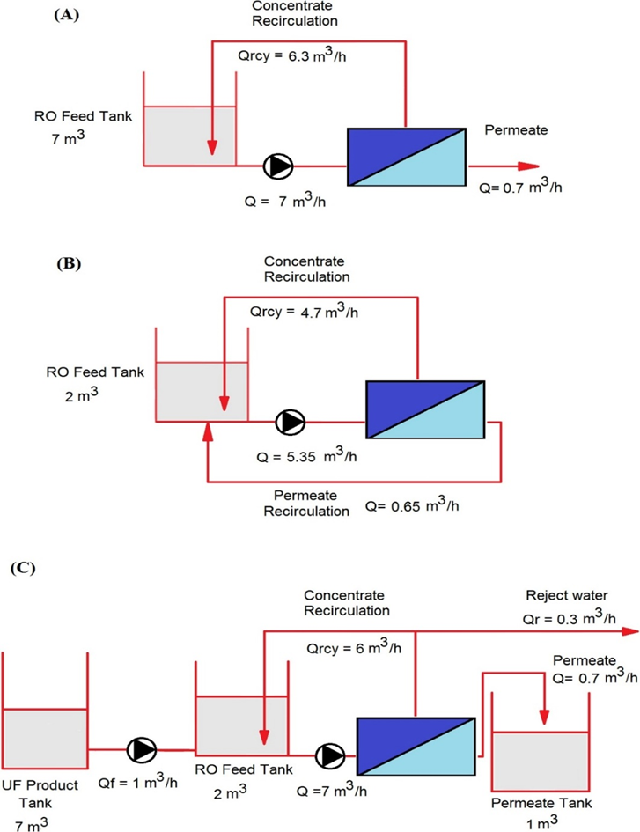
Figure S16. Operational modes of the pilot scale reverse osmosis process. (A) Batch (or concentrated) mode of operation, (B) Complete recycle mode of operation, (C) Continuous mode of operation. Reproduced with permission (Sahinkaya et al. 2019). Copyright 2019, Elsevier.
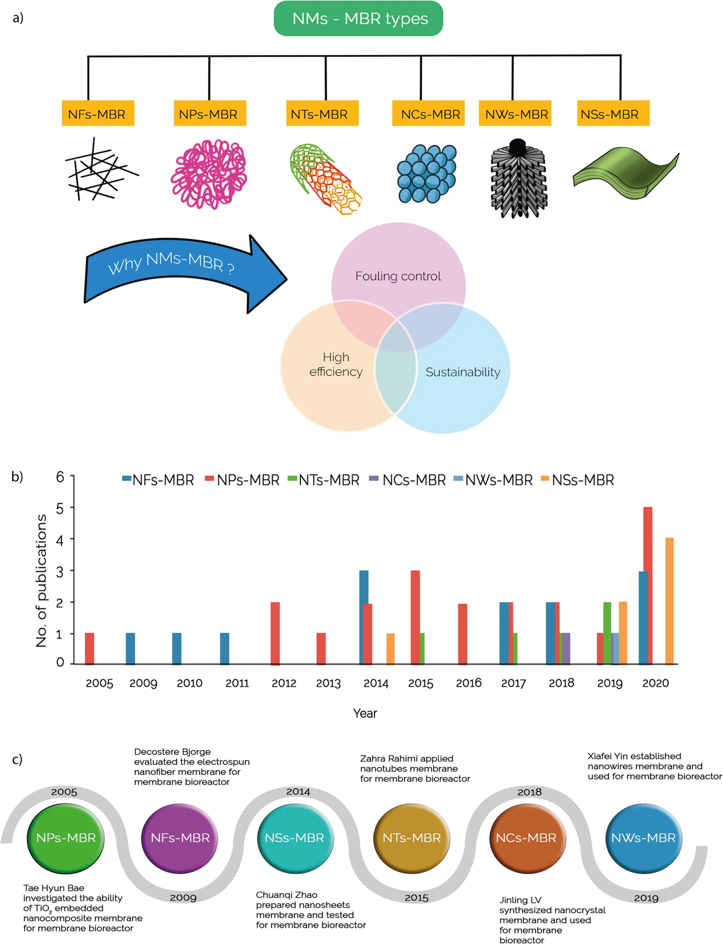
Figure S17. Types and benefits of different nanomaterials membrane bioreactor (NMs-MBR) technology and several publications are observed related to these NMs-MBR technology with their historical timeline. a. Examples of commonly used nanomaterials membrane bioreactor (NMs-MBR) technology (left to right) nanofibers membrane bioreactor (NFs-MBR), nanoparticles membrane bioreactor (NPs-MBR), nanotubes membrane bioreactor (NTs-MBR), nanocrystals membrane bioreactor (NCs-MBR), nanowires membrane bioreactor (NWs-MBR), nanosheets membrane bioreactor (NSs-MBR), and the advantages of using NMs-MBR technology are fouling control, high efficiency and sustainability. b. Diagram of the total number of publications related to different types of NMs-MBR technology. Until 3rd August 2020, which were collected from the web of science scientific database. c. Historical development of NMs-MBR technology for wastewater treatment. In 2005, Tae-Hyun Bae investigated the ability of TiO2-embedded nanocomposite membrane for NPs-MBR , In 2009, Decostere Bjorge evaluated the electrospun NFs-MBR , In 2014, Chuanqi Zhao prepared nanosheets membrane and tested for NSs-MBR , In 2015, Zahra Rahimi applied NTs-MBR , In 2018, Jinling Lv synthesized nanocrystal membrane and used for NCs-MBR and In 2019, Xiafei Yin established nanowires membrane and used for membrane bioreactor (NWs-MBR) (Pervez et al. 2020).

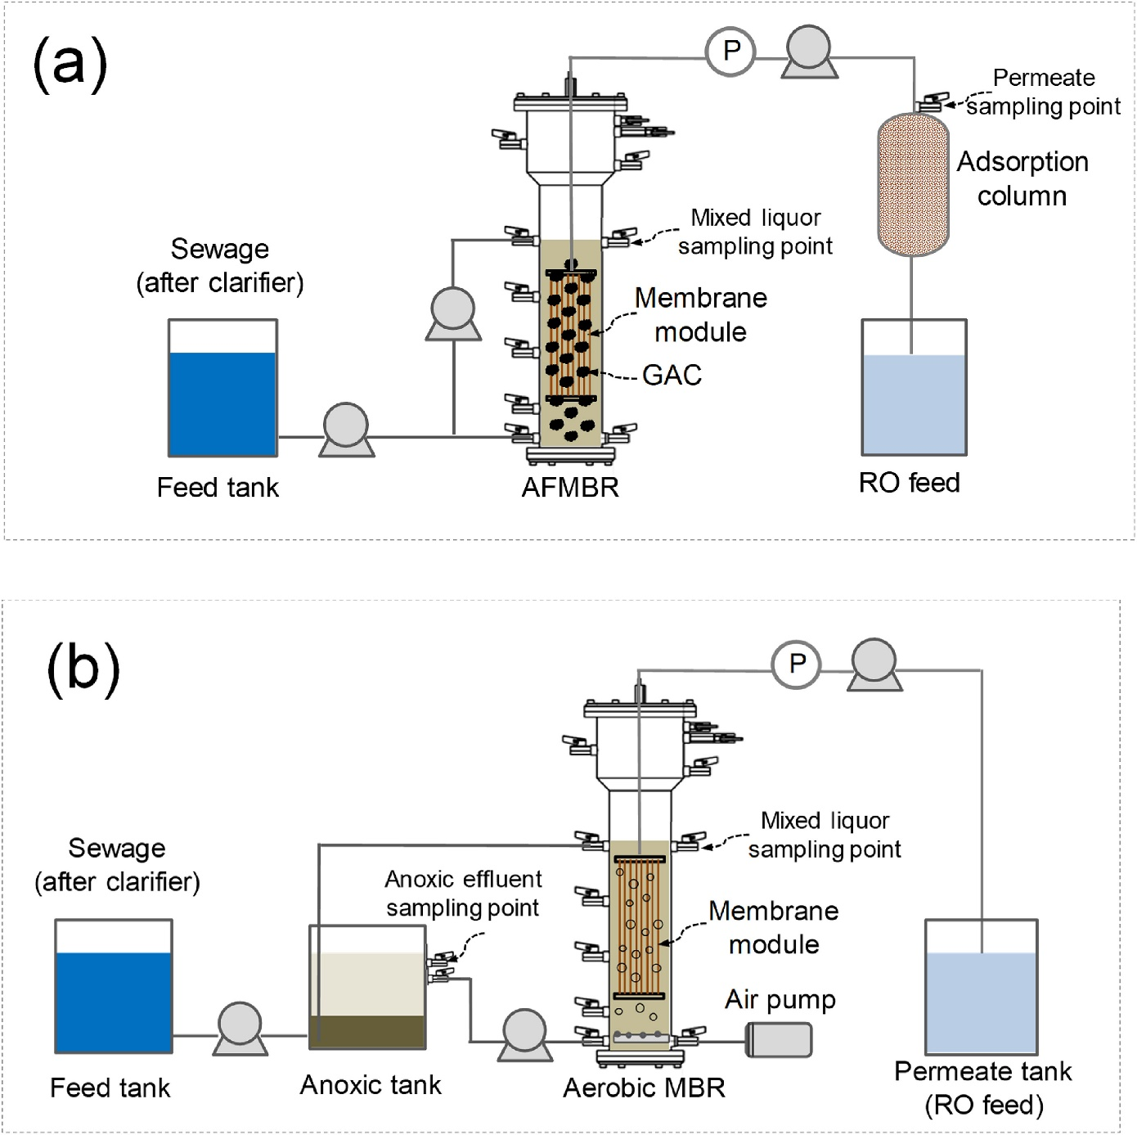
Figure S18. Schematic diagrams of AFMBR (a) and anoxic-aerobic MBR (b). Reproduced with permission (Li et al. 2020). Copyright 2020, Elsevier.

References
Ağtaş M, Yılmaz Ö, Dilaver M, et al (2021) Pilot-scale ceramic ultrafiltration/nanofiltration membrane system application for caustic recovery and reuse in textile sector. Environ Sci Pollut Res 2021 2830 28:41029–41038. https://doi.org/10.1007/S11356-021-13588-0
Ali SS, Al-Tohamy R, Koutra E, et al (2021) Coupling azo dye degradation and biodiesel production by manganese-dependent peroxidase producing oleaginous yeasts isolated from wood-feeding termite gut symbionts. Biotechnol Biofuels 2021 141 14:1–25. https://doi.org/10.1186/S13068-021-01906-0
Amare E, Kebede F, Mulat W (2017) Analysis of heavy metals, physicochemical parameters and effect of blending on treatability of wastewaters in Northern Ethiopia. Int J Environ Sci Technol 2017 148 14:1679–1688. https://doi.org/10.1007/S13762-017-1270-X
Arcanjo GS, Mounteer AH, Bellato CR, et al (2018) Heterogeneous photocatalysis using TiO2 modified with hydrotalcite and iron oxide under UV–visible irradiation for color and toxicity reduction in secondary textile mill effluent. J Environ Manage 211:154–163. https://doi.org/10.1016/J.JENVMAN.2018.01.033
Avvannavar SM, Mani M, Kumar N (2008) An integrated assessment of the suitability of domestic solar still as a viable safe water technology for India
Broadbent AD (2001) Basic Principles of Textile Coloration 2001 Society of Dyers and Colourists. Soc Dye Colour
Chakraborty JN, Jaruhar P (2014) Dyeing of cotton with sulphur dyes using alkaline catalase as reduction catalyst. Indian J Fibre Text Res 39:303–309
Chandanshive V V., Rane NR, Tamboli AS, et al (2017) Co-plantation of aquatic macrophytes Typha angustifolia and Paspalum scrobiculatum for effective treatment of textile industry effluent. J Hazard Mater 338:47–56. https://doi.org/10.1016/J.JHAZMAT.2017.05.021
Chandanshive V, Kadam S, Rane N, et al (2020) In situ textile wastewater treatment in high rate transpiration system furrows planted with aquatic macrophytes and floating phytobeds. Chemosphere 252:126513. https://doi.org/10.1016/J.CHEMOSPHERE.2020.126513
Chiou MS, Li HY (2002) Equilibrium and kinetic modeling of adsorption of reactive dye on cross-linked chitosan beads. J Hazard Mater 93:233–248. https://doi.org/10.1016/S0304-3894(02)00030-4
Choumane FZ, Benguella B, Maachou B, Saadi N (2017) Valorisation of a bioflocculant and hydroxyapatites as coagulation-flocculation adjuvants in wastewater treatment of the steppe in the wilaya of Saida (Algeria). Ecol Eng 107:152–159. https://doi.org/10.1016/J.ECOLENG.2017.07.013
Ding Y, Szymczyk M, Mehraban N, et al (2020) Molecular and excited state properties of photostable yellow disperse dyes. J Mol Struct 1207:127815. https://doi.org/10.1016/J.MOLSTRUC.2020.127815
Dos Santos AB, Cervantes FJ, Van Lier JB (2003) Azo dye reduction by thermophilic anaerobic granular sludge, and the impact of the redox mediator anthraquinone-2,6-disulfonate (AQDS) on the reductive biochemical transformation. Appl Microbiol Biotechnol 2004 641 64:62–69. https://doi.org/10.1007/S00253-003-1428-Y
Dutta S, Gupta B, Srivastava SK, Gupta AK (2021) Recent advances on the removal of dyes from wastewater using various adsorbents: a critical review. Mater Adv 2:4497–4531. https://doi.org/10.1039/D1MA00354B
EL-Mekkawi DM, Abdelwahab NA, Mohamed WAA, et al (2020) Solar photocatalytic treatment of industrial wastewater utilizing recycled polymeric disposals as TiO2 supports. J Clean Prod 249:119430. https://doi.org/10.1016/J.JCLEPRO.2019.119430
Guadie A, Tizazu S, Melese M, et al (2017) Biodecolorization of textile azo dye using Bacillus sp. strain CH12 isolated from alkaline lake. Biotechnol Reports 15:92–100. https://doi.org/10.1016/J.BTRE.2017.06.007
Hassan MM, Carr CM (2018) A critical review on recent advancements of the removal of reactive dyes from dyehouse effluent by ion-exchange adsorbents. Chemosphere 209:201–219. https://doi.org/10.1016/J.CHEMOSPHERE.2018.06.043
Hubadillah SK, Othman MHD, Tai ZS, et al (2020) Novel hydroxyapatite-based bio-ceramic hollow fiber membrane derived from waste cow bone for textile wastewater treatment. Chem Eng J 379:122396. https://doi.org/10.1016/J.CEJ.2019.122396
Hussain Z, Arslan M, Shacir G, et al (2019) Remediation of textile bleaching effluent by bacterial augmented horizontal flow and vertical flow constructed wetlands: A comparison at pilot scale. Sci Total Environ 685:370–379. https://doi.org/10.1016/J.SCITOTENV.2019.05.414
Hynes NRJ, Kumar JS, Kamyab H, et al (2020) Modern enabling techniques and adsorbents based dye removal with sustainability concerns in textile industrial sector -A comprehensive review. J Clean Prod 272:122636. https://doi.org/10.1016/j.jclepro.2020.122636
Jebapriya GR, Gnanadoss JJ (2013) Bioremediation of Textile Dye Using White Rot Fungi: A Review. Int J Curr Res Rev 05:5
Kadam SK, Watharkar AD, Chandanshive V V., et al (2018) Co-planted floating phyto-bed along with microbial fuel cell for enhanced textile effluent treatment. J Clean Prod 203:788–798. https://doi.org/10.1016/J.JCLEPRO.2018.08.336
Kaur P, Kushwaha JP, Sangal VK (2018) Electrocatalytic oxidative treatment of real textile wastewater in continuous reactor: Degradation pathway and disposability study. J Hazard Mater 346:242–252. https://doi.org/10.1016/J.JHAZMAT.2017.12.044
Khan S, Malik A (2014) Environmental and Health Effects of Textile Industry Wastewater. Environ Deterior Hum Heal Nat Anthropog Determ 9789400778900:55–71. https://doi.org/10.1007/978-94-007-7890-0_4
Khatri A, Peerzada MH, Mohsin M, White M (2015) A review on developments in dyeing cotton fabrics with reactive dyes for reducing effluent pollution. J Clean Prod 87:50–57. https://doi.org/10.1016/J.JCLEPRO.2014.09.017
Kishor R, Purchase D, Saratale GD, et al (2021) Ecotoxicological and health concerns of persistent coloring pollutants of textile industry wastewater and treatment approaches for environmental safety. J Environ Chem Eng 9:105012. https://doi.org/10.1016/J.JECE.2020.105012
Li Y, Sim LN, Ho JS, et al (2020) Integration of an anaerobic fluidized-bed membrane bioreactor (MBR) with zeolite adsorption and reverse osmosis (RO) for municipal wastewater reclamation: Comparison with an anoxic-aerobic MBR coupled with RO. Chemosphere 245:125569. https://doi.org/10.1016/J.CHEMOSPHERE.2019.125569
Lu NC, Liu JC (2010) Removal of phosphate and fluoride from wastewater by a hybrid precipitation–microfiltration process. Sep Purif Technol 74:329–335. https://doi.org/10.1016/J.SEPPUR.2010.06.023
Mani S, Chowdhary P, Bharagava RN (2019) Textile Wastewater Dyes: Toxicity Profile and Treatment Approaches. Emerg Eco-Friendly Approaches Waste Manag 219–244. https://doi.org/10.1007/978-981-10-8669-4_11
Mathur N, Bhatnagar P, Sharma P (2012) Review of the Mutagenicity of Textile Dye Products. Univers J Env Res Technol 2:1–18
Miklos DB, Remy C, Jekel M, et al (2018) Evaluation of advanced oxidation processes for water and wastewater treatment – A critical review. Water Res 139:118–131. https://doi.org/10.1016/J.WATRES.2018.03.042
Millington KR, Fincher KW, King AL (2007) Mordant dyes as sensitisers in dye-sensitised solar cells. Sol Energy Mater Sol Cells 91:1618–1630. https://doi.org/10.1016/J.SOLMAT.2007.05.020
Morsy SAGZ, Ahmad Tajudin A, Ali MSM, Shariff FM (2020) Current Development in Decolorization of Synthetic Dyes by Immobilized Laccases. Front Microbiol 11:2350. https://doi.org/10.3389/FMICB.2020.572309/BIBTEX
Nguyen TA, Juang RS (2013) Treatment of waters and wastewaters containing sulfur dyes: A review. Chem Eng J 219:109–117. https://doi.org/10.1016/J.CEJ.2012.12.102
Oktem YA, Yuzer B, Aydin MI, et al (2019) Chloride or sulfate? Consequences for ozonation of textile wastewater. J Environ Manage 247:749–755. https://doi.org/10.1016/J.JENVMAN.2019.06.114
Pearce CI, Lloyd JR, Guthrie JT (2003) The removal of colour from textile wastewater using whole bacterial cells: a review. Dye Pigment 58:179–196. https://doi.org/10.1016/S0143-7208(03)00064-0
Pei L, Liu J, Wang J (2017) Study of dichlorotriazine reactive dye hydrolysis in siloxane reverse micro-emulsion. J Clean Prod 165:994–1004. https://doi.org/10.1016/J.JCLEPRO.2017.07.185
Pervez MN, Balakrishnan M, Hasan SW, et al (2020) A critical review on nanomaterials membrane bioreactor (NMs-MBR) for wastewater treatment. npj Clean Water 2020 31 3:1–21. https://doi.org/10.1038/s41545-020-00090-2
R Ananthashankar AG (2013) Production, Characterization and Treatment of Textile Effluents: A Critical Review. J Chem Eng Process Technol 05:1–18. https://doi.org/10.4172/2157-7048.1000182
Sahinkaya E, Tuncman S, Koc I, et al (2019) Performance of a pilot-scale reverse osmosis process for water recovery from biologically-treated textile wastewater. J Environ Manage 249:109382. https://doi.org/10.1016/J.JENVMAN.2019.109382
Samsami S, Mohamadi M, Sarrafzadeh MH, et al (2020) Recent advances in the treatment of dye-containing wastewater from textile industries: Overview and perspectives. Process Saf Environ Prot 143:138–163. https://doi.org/10.1016/j.psep.2020.05.034
Scalbi S, Tarantini M, Mattioli D (2005) Efficient use of water in the textile finishing industry. https://doi.org/10.4/JQUERY-UI.MIN.JS
Suteu D, Zaharia C, Malutan T (2012) Biosorbents based on lignin used in biosorption processes from wastewater treatment: A review. Lignin Prop Appl Biotechnol Bioenergy 279–306
Tara N, Arslan M, Hussain Z, et al (2019) On-site performance of floating treatment wetland macrocosms augmented with dye-degrading bacteria for the remediation of textile industry wastewater. J Clean Prod 217:541–548. https://doi.org/10.1016/J.JCLEPRO.2019.01.258
Tomei MC, Soria Pascual J, Mosca Angelucci D (2016) Analysing performance of real textile wastewater bio-decolourization under different reaction environments. J Clean Prod 129:468–477. https://doi.org/10.1016/J.JCLEPRO.2016.04.028
Vacchi FI, Von der Ohe PC, Albuquerque AF de, et al (2016) Occurrence and risk assessment of an azo dye – The case of Disperse Red 1. Chemosphere 156:95–100. https://doi.org/10.1016/J.CHEMOSPHERE.2016.04.121
Walters, A., Santillo, D., & Johnston P (2005) An overview of textiles processing and related environmental concerns
Watharkar AD, Kadam SK, Khandare R V., et al (2018) Asparagus densiflorus in a vertical subsurface flow phytoreactor for treatment of real textile effluent: A lab to land approach for in situ soil remediation. Ecotoxicol Environ Saf 161:70–77. https://doi.org/10.1016/J.ECOENV.2018.05.078
Zheng T, Wang Q, Zhang T, et al (2015) Microbubble enhanced ozonation process for advanced treatment of wastewater produced in acrylic fiber manufacturing industry. J Hazard Mater 287:412–420. https://doi.org/10.1016/J.JHAZMAT.2015.01.069
Zinatloo-Ajabshir S, Salavati-Niasari M, Zinatloo-Ajabshir Z (2017) Facile size-controlled preparation of highly photocatalytically active praseodymium zirconate nanostructures for degradation and removal of organic pollutants. Sep Purif Technol 177:110–120. https://doi.org/10.1016/J.SEPPUR.2016.12.043

